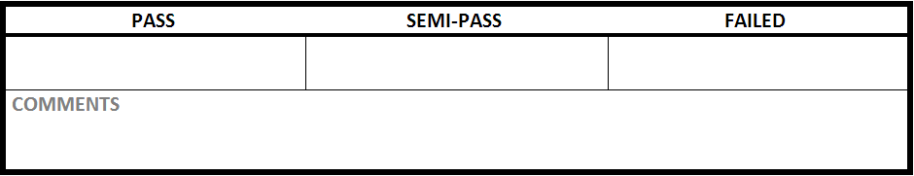

|  |  |
| --- | --- |
| Test Case #:ITM1.3 | Test Case Name: Create Item |
| System: Rec Warehouse | Subsystem:Item |
| Designed by: Rec Team | Design Date: October 2013 |
| Executed by: | Execution Date: |

|  |
| --- |
| Short Description:Create a item with incorrect data |

|  |
| --- |
| Preconditions:at the main item page with a new item to add |

|  |  |  |  |  |
| --- | --- | --- | --- | --- |
| Step | Action | Expected System Response | Pass/Fail | Comment |
| 1 | click ‘Item Management" | changes to the create item screen | Pass |  |
| 2 | enter ‘Garmin international’ into Vendor Name | displays "Garmin international’ in Vendor Name | Pass |  |
| 3 | enter ‘Nuvi’ into Product Line | displays Nuvi in Product Line | Pass |  |
| 4 | enter ‘Something’ into Vendor Id | displays ‘Something’ in Vendor Id | Pass |  |
| 5 | enter '1624' into Item UPC | displays '1624' in Item UPC | Pass |  |
| 6 | enter ‘budget Garmin GPS with lifetime maps.’ into item Description | displays ‘budget Garmin GPS with lifetime maps.’ in item Description | Pass |  |
| 7 | select ‘Automotive’ in Department | displays ‘Automotive’ in Department | Pass |  |
| 8 | select ‘GPS’ in category | displays ‘GPS’ in category | Pass |  |
| 9 | select 'Automotive GPS' in subcategory | displays 'Automotive GPS' in subcategory | Pass |  |
| 10 | enter ‘fifty ninety nine’ into sell price | displays ‘fifty ninety nine' into sell price | Pass |  |
| 11 | enter ‘ten’ into restricted age | displays 'ten' in restricted age | Pass |  |
| 12 | click Create New Item | check Post conditions | Fail | It's also saying that MSRP is required and is deleting the 'Something' that was typed into the Vendor ID, simply telling us that the field is required. |

|  |
| --- |
| Postconditions: does not create a item in the database. shows errors in Item UPC, Sell Price, Restricted Age |